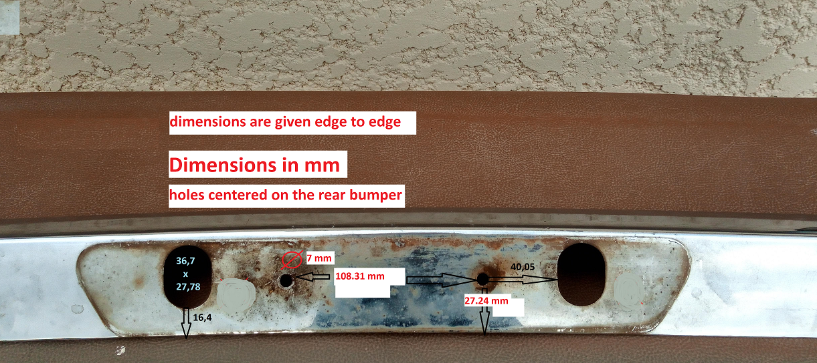
holes centered on the rear bumper to receive plate lighting plate

